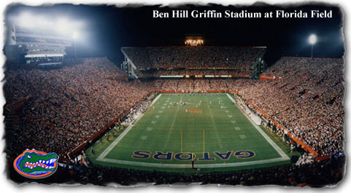
Victory 2006



Join former Gator great, Danny Wuerffel, and experience the amazing 2006 Gator Football season!
Don’t miss exclusive interviews with Urban Meyer, Chris Leak and more. Enjoy classic Gator Songs like, “We are the Boys”, “Jaws, Go Gators” and a new favorite, “Kernkraft 400” by Zombie Nation. Relive the excitement. Feel the dream. Learn what it means to bleed orange and blue.
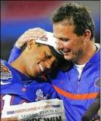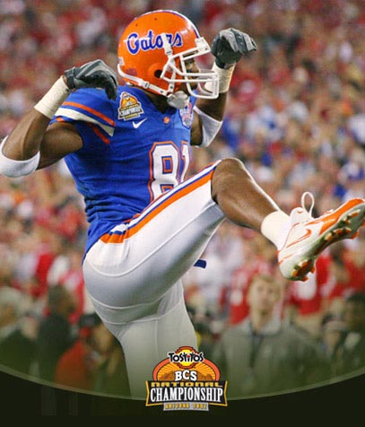

.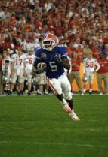
See action packed highlights from the season and the championship game from the field! Witness the dedication and true spirit that can only be found at the University of Florida!

